**AWS CLOUD COMPUTING**

**Practical no.5**

**AIM:** *Create an API gateway and integrate it with lambda function using AWS Console .*

As earlier, we have successfully created a lambda function so continuing with the practical 4 .

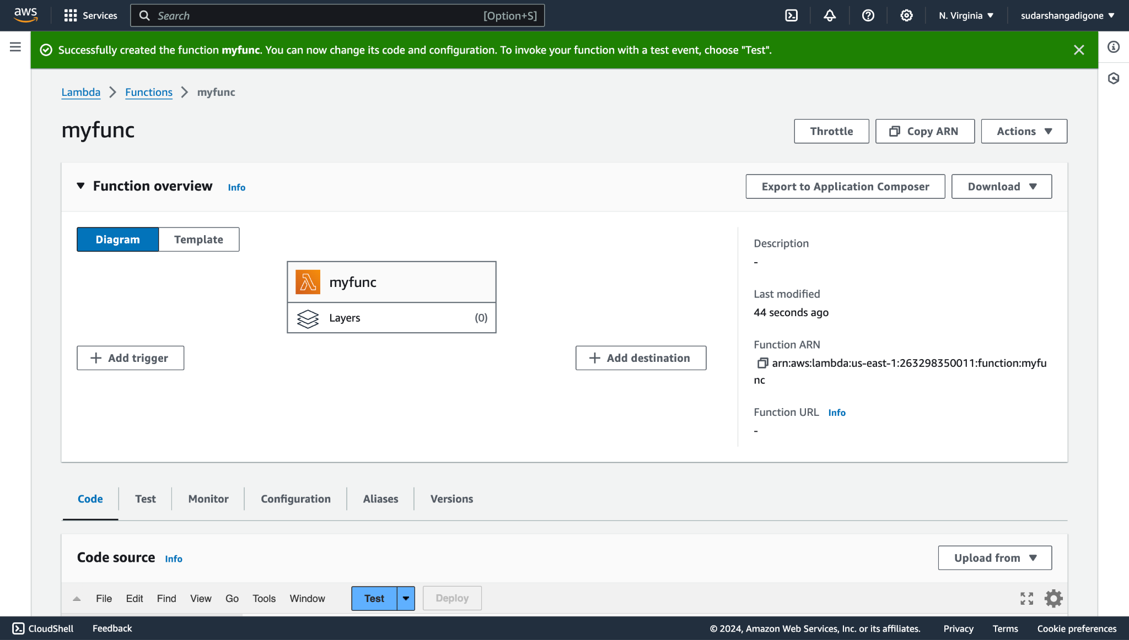

## 

## 

## 

## 

## 

## 

## 

## **Step 1. Click on Add trigger and search for API Gateway.**

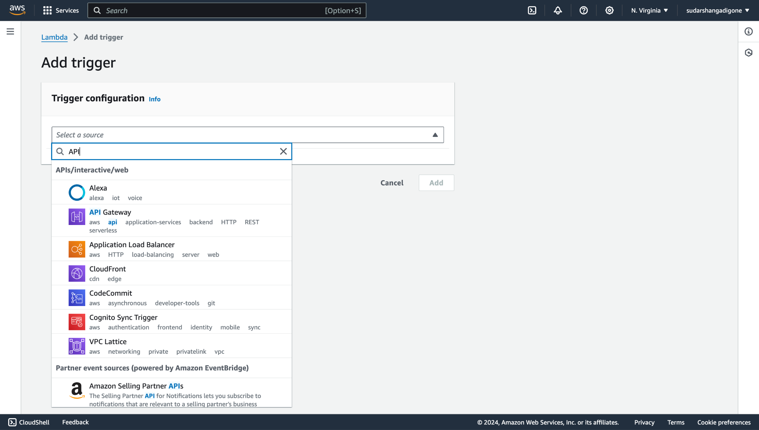

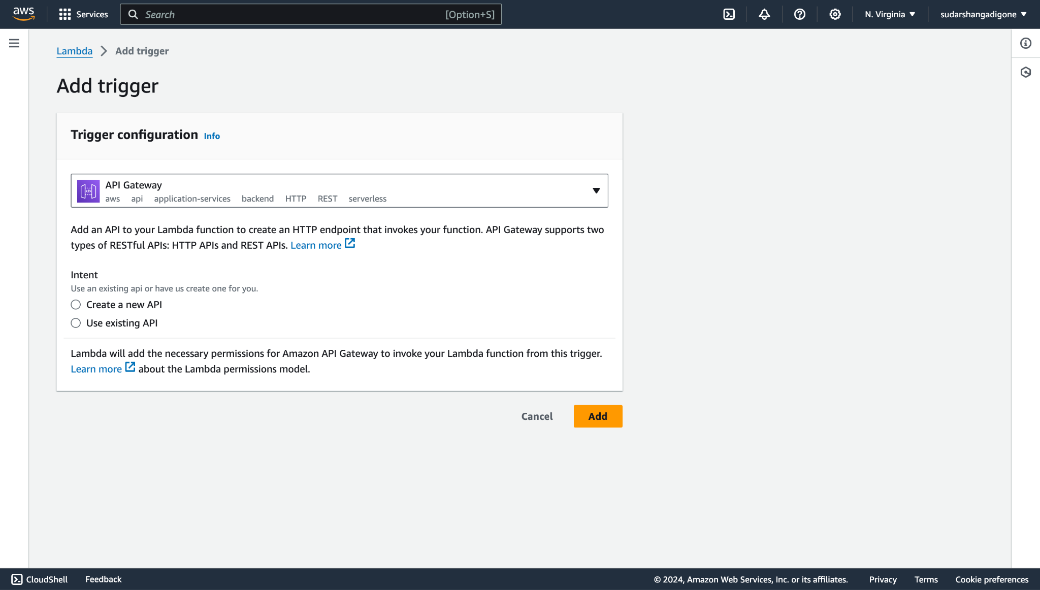

## **Step 2. Click on Create a new API or you can also select use existing API if already created. Also, select the OPEN option in security. Then click on Add.**

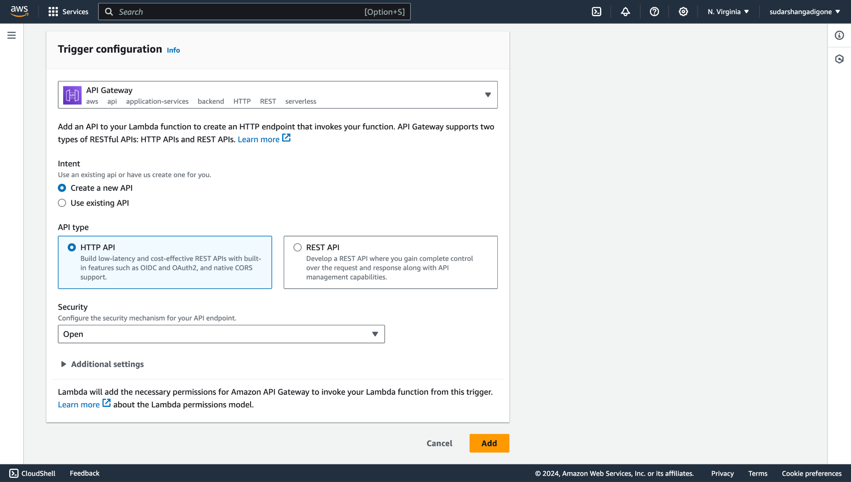

## 

## **Step 3.Create a new event and save it.**

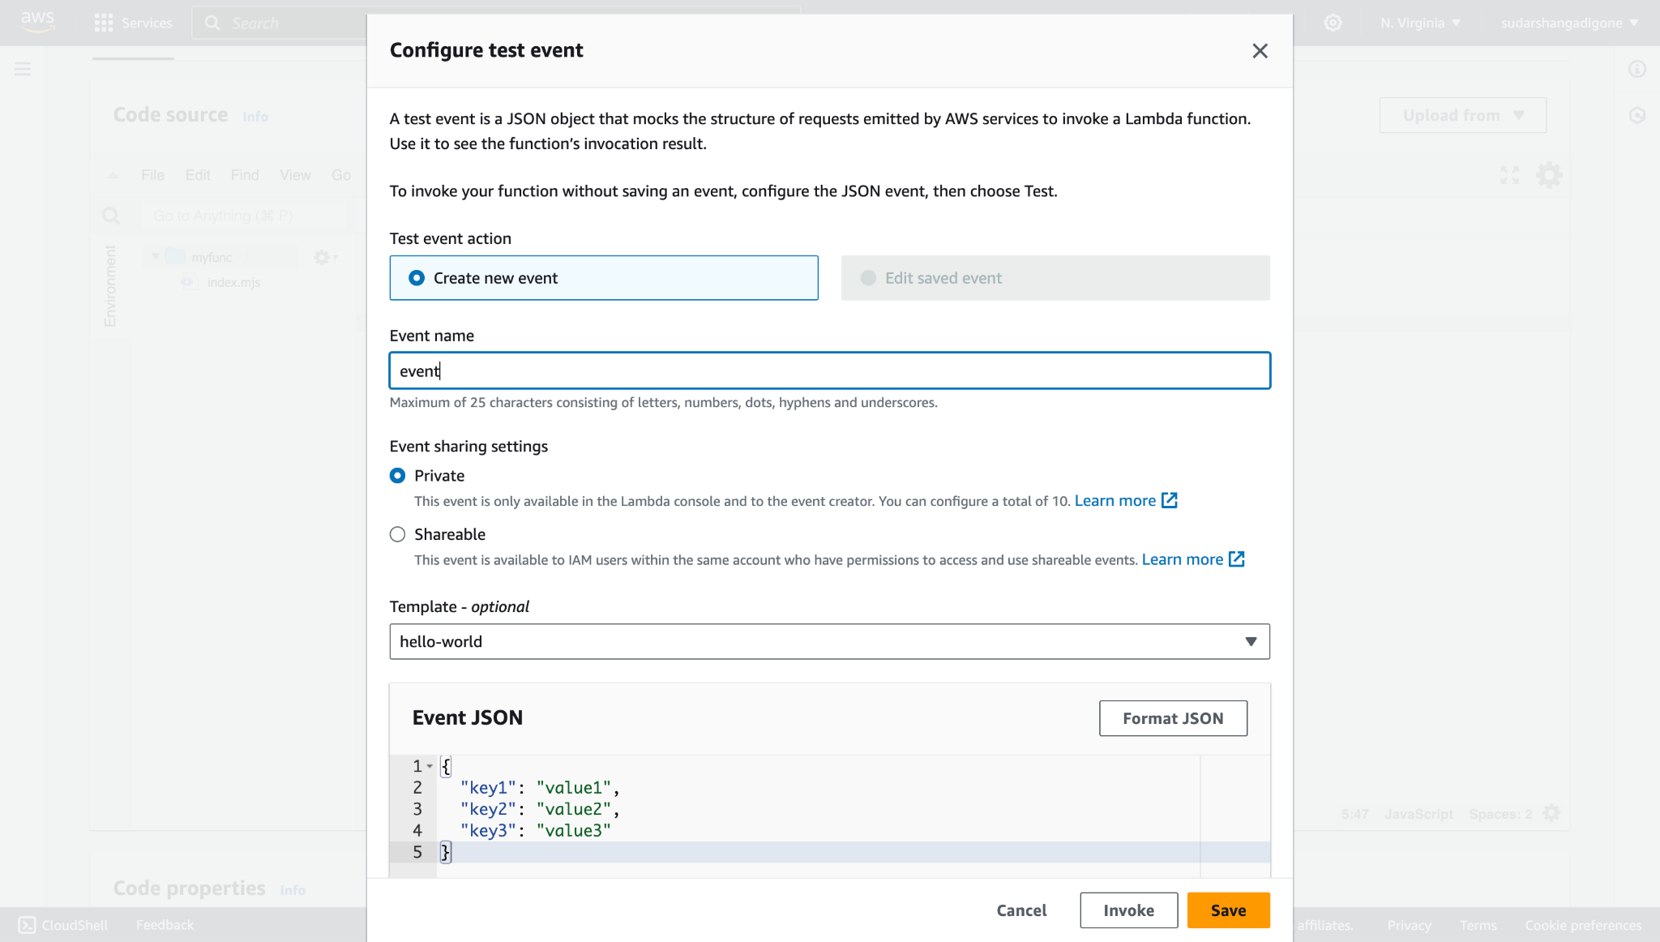

## 

## 

## 

## **Step 4.After creating API click on Code source and test the code.**

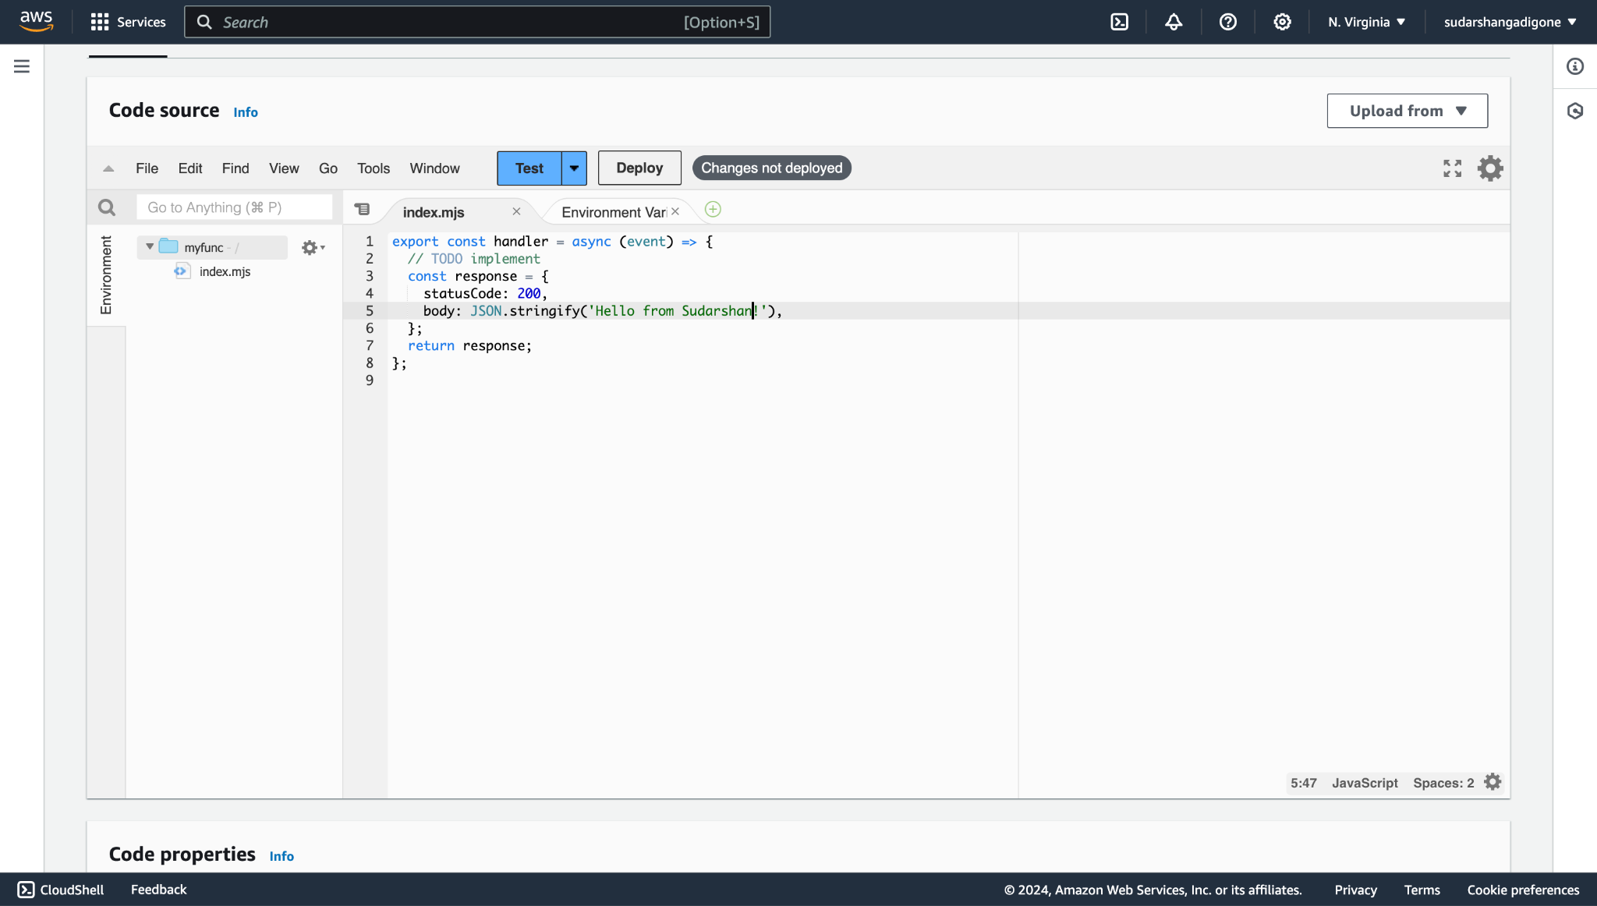

## 

## 

## 

## 

## 

## 

## 

## 

## **Step 5. First deploy your code and test the data you will get the following output.**

## 

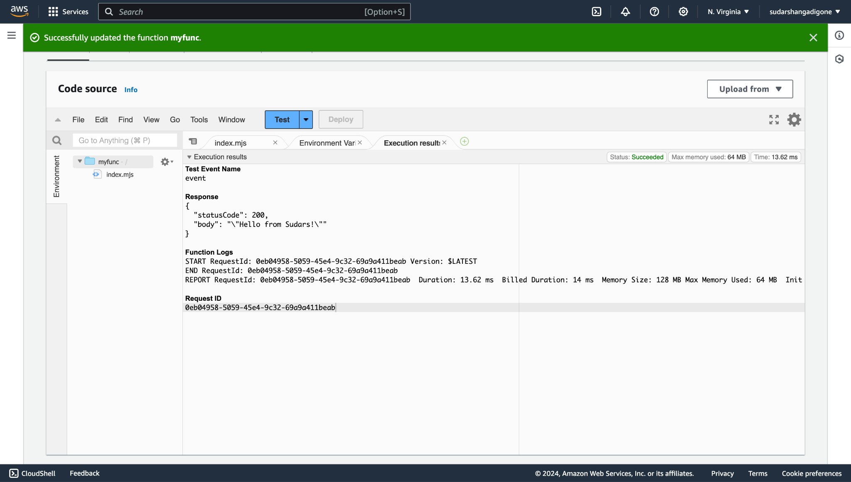

**CONCLUSION:**

Thus we have successfully integrated API gateway with lambda function using AWS Console .